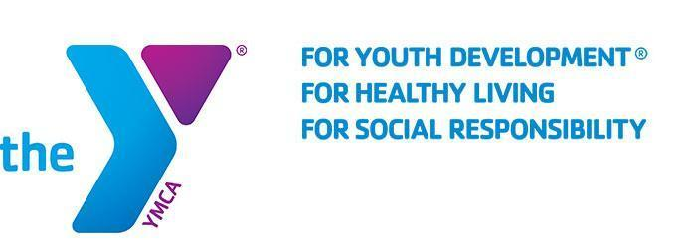
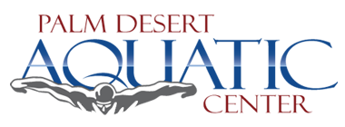
FOR IMMEDIATE RELEASE
April 11, 2018

THE PALM DESERT AQUATIC CENTER AND FAMILY YMCA OF THE DESERT ANNOUNCE EASTER UNDERWATER EGG HUNT

PALM DESERT, CA -- The Palm Desert Aquatic Center, in coordination with the Family YMCA of the Desert, will host an Easter Sunday “Underwater Egg Hunt” at the Palm Desert Aquatic Center on April 21st, 2019. The admission fee is $4.00 per person and begins at 12:30 PM.

Children, ages 2-13, will participate in a completely unique egg hunt where they will swim for thousands of floating eggs! The first egg drop is scheduled for 1:00 PM and three more are scheduled every hour at: 2:00, 3:00, and 4:00 PM. For the safety of everybody, children ages 2-5 must be accompanied by an adult and only U.S. Coast Guard Flotation devices are permitted inside the pool.

Additional information can be found at: www.pdpool.com or calling 760-565-7467.

About the Family YMCA of the Desert
The Family YMCA of the Desert is the largest provider of licensed child care in the Coachella Valley, with facilities from Palm Springs to Mecca. We serve over 3,500 local kids and families each day at our forty sites. We also provide a variety of programs, camps, and other events and activities for members of our community. The primary focus of the Y is to reinforce caring, honesty, respect, and responsibility while also helping kids to develop social skills, confidence, leadership, and fitness.

About the Palm Desert Aquatic Center
Splash into year-round fun at the Palm Desert Aquatic Center featuring three pools, multiple slides, diving boards, and a variety of play features designed to delight water lovers of all ages. All or part of the 8-acre facility can be rented for private parties, corporate events, swimming competitions, and other special occasions. Located in Palm Desert's Civic Center Park, the Aquatic Center is owned by the City of Palm Desert and operated by Family YMCA of the Desert.

